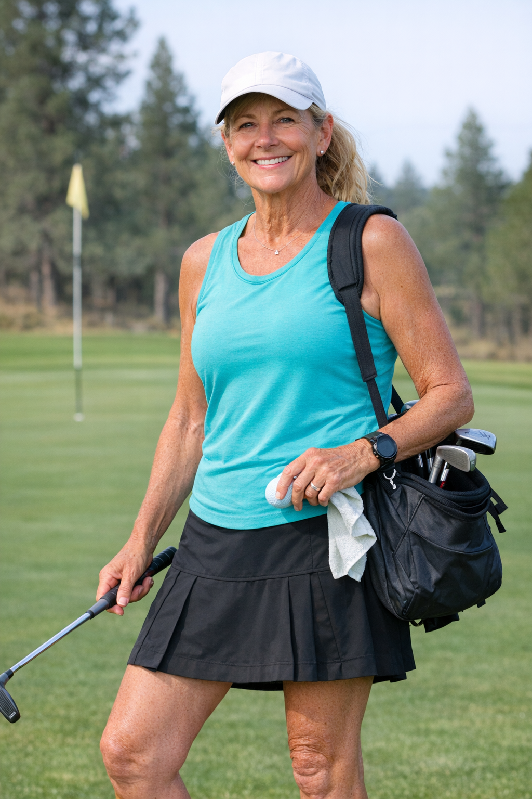
Diane Rourke
Retired Teacher & Recreational Speedgolfer

Bio
Diane is a 61-year-old retired high school PE teacher from Bend, Oregon who took up speedgolf two years ago after her running coach suggested it as a low-impact alternative to road racing. She plays once or twice a week with a small group of friends and isn't chasing trophies. She just loves that it keeps her moving and social. She uses her phone sparingly and prefers simple, no-fuss tools.
Quote
“I don’t need fancy dashboards. I just want to know if I did better than last Tuesday.”
User Matrix
Diane sits in the lower-left quadrant: casual speedgolf interest, casual tech use.
Axis | Diane's Position
Speed-run interest | Casual
Use of technology | Casual
Wants & Needs
- Simple round logging — strokes & time only
- Easy week-over-week progress view
- Group play scheduling with friends
- Encouragement, not competition
- Large, readable text and clear buttons
Pain Points
- Apps feel overwhelming and cluttered
- Doesn’t want to create yet another account
- Can’t log a round while running — too fiddly
- No easy way to share results with friends casually
- Feels the sport isn’t designed “for her age”
Apps & Tech Used
Tool | How she uses it
iPhone Timer | Times her runs between holes
Notes app | Jots down strokes manually after each hole
Facebook Groups | Coordinates with her regular playing group

